**Using CentOS to build the XMLFoundation HTTP server for Android**

This was written on December 4, 2013 using current versions of all the necessary components on 64 bit CentOS.

Download and decompress the following:

Java Development Kit (JDK): <http://www.oracle.com/technetwork/java/javase/downloads/index.html>

Android NDK : <http://developer.android.com/tools/sdk/ndk/index.html>

Android SDK : <http://developer.android.com/sdk/index.html>

XMLFoundation: <https://skydrive.live.com/redir?resid=D7EC275E76D295CF!585>

Rename LinuxAndroid.mk to Android.mk by doing this:

cd XMLFoundation/Examples/Android/Server/jni

cp Android.mk WindowsAndroid.mk

rm Android.mk

cp LinuxAndroid.mk Android.mk

Here you can see the downloads and the equivalent directories that they have been decompressed to. In gedit (next page) - you see how the environment must be setup for this directory configuration.

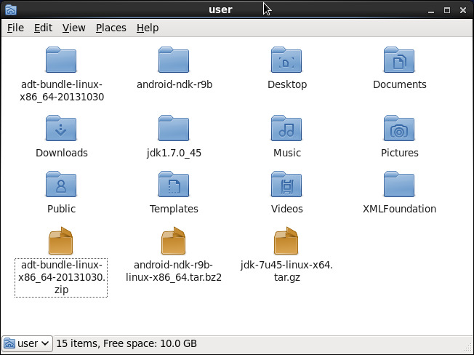

$ gedit .bashrc 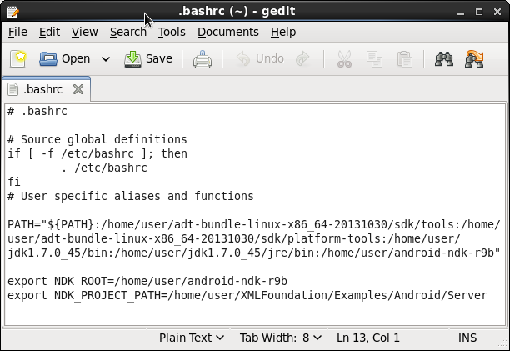

This lists the individual PATH entries that MUST appear in the PATH=

/home/user/adt-bundle-linux-x86_64-20131030/sdk/tools

/home/user/adt-bundle-linux-x86_64-20131030/sdk/platform-tools

/home/user/jdk1.7.0_45/bin

/home/user/jdk1.7.0_45/jre/bin

/home/user/android-ndk-r9b

And make sure you export the two NDK_ variables

You must also install the 32 bit runtime

or Eclipse will fail and give a false error that it cannot find /sdk/build-tools/android-4.3/aapt or /sdk/build-tools/android-4.3/adb

# yum install glibc.i686

# yum install zlib.i686

# yum install libstdc++

# yum install libstdc++.so.6

Additioanlly you need OpenGL for the Android emulator to work.

# yum install mesa-libGLU-devel

Mesa-libGLU-devel is likely the only thing you NEED to get the emulator working – but I added Mesa-libGLU-devel at the same time as these for some GUI work I am doing.

# yum install freeglut freeglut-devel libX11-devel

Reboot the machine, or restart the graphical shell to pick up the new environment settings.

Start a terminal window and type

# ndk-build

The following page contains the output you will see when the XMLFoundation library is built.

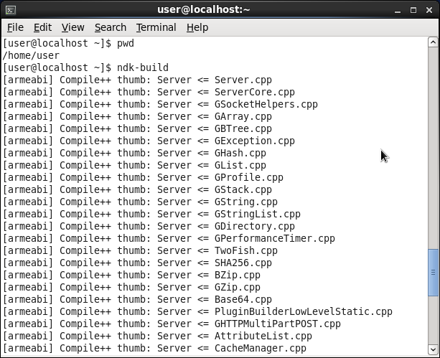

Setup an emulator definition. At the prompt type “android”. To start the SDK manager.

[root@localhost user]# android

Then “Manage AVDs…” as shown in the next image

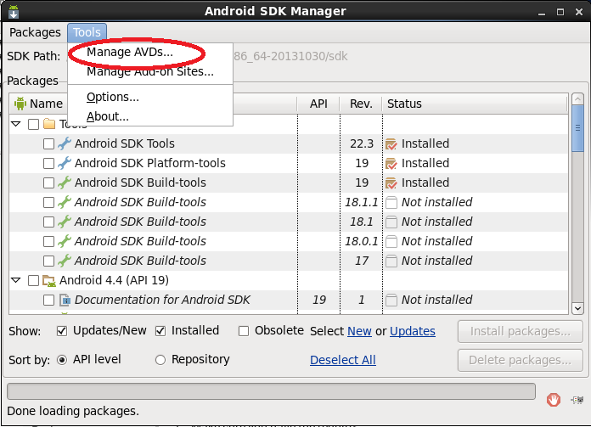

Create a new definition - then start it now or Eclipse can start it later.

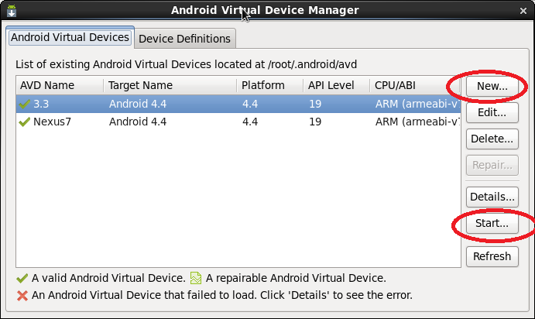

Start ADT and import the Android example from the XMLFoundation:

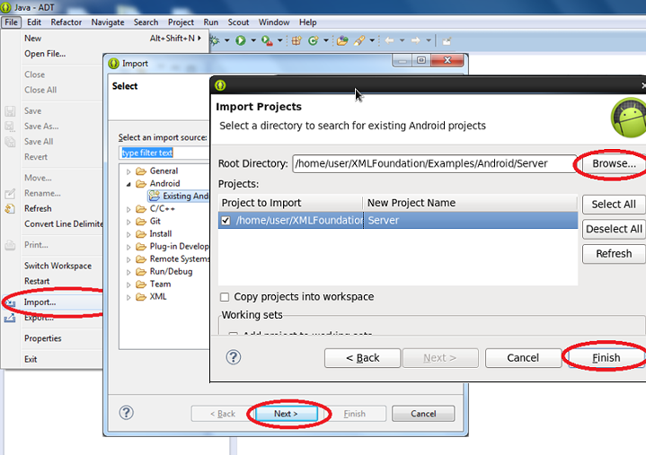

Open “Window..Navigator”, “Run” the project

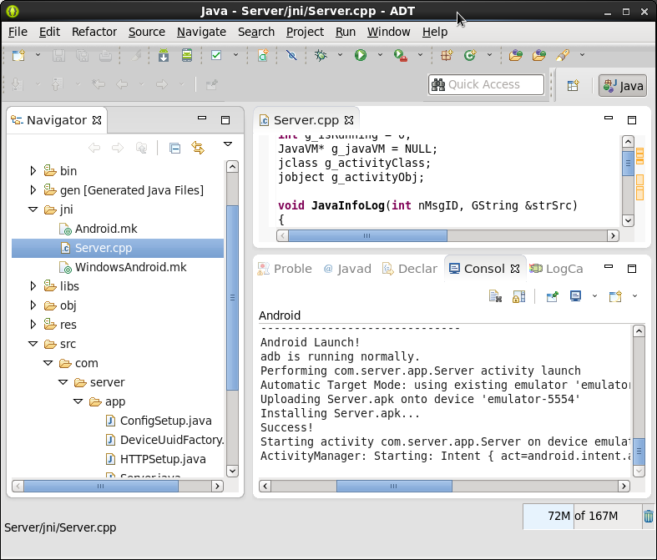

When the app starts on the phone, press Start.

